SIMATS ENGINEERING
(SAVEETHA SCHOOL OF ENGINEERING)
Department of Computer Science and Engineering
CO2 ASSESSMENT TOOL 2 – ARCHITECTURE DESIGN ASSIGNMENT

Course Code: CSA10
Course Title: Software Engineering
CO Assessed: CO2
Assessment: Assessment Tool 2 – Architecture Design Assignment
Weightage: 20% Total Marks: 25
CO2 Statement: Perform detailed requirements analysis, design scalable architectures, and prioritize features with a focus on cross-disciplinary skills.

Student Name: G.pradeep ranga reddy
Reg. No.: 192311289
Date: 14-08-2026
Duration: 60 minutes
Assigned Problem Statement:
Intelligent Disaster Early Warning and Evacuation Management System
Code of Conduct
I G.pradeep ranga reddy 192311289
(Name / Reg No) certify that this submission is my original work and that I have adhered to the guidelines specified for this assessment. I understand that any violation of academic integrity rules will result in disciplinary action.
Signature of the Student:


1. Analyze System Requirements

1.1 Problem Statement & System Objectives
The assigned problem statement is the “Intelligent Disaster Early Warning and Evacuation Management System (IDEWEMS).” The system aims to detect natural and man-made disasters (floods, earthquakes, cyclones, tsunamis, wildfires) as early as possible using sensor, satellite and citizen-reported data, assess risk in real time, and coordinate a rapid, life-saving response. The core objectives are:
- Continuously monitor environmental and infrastructural data to detect early indicators of a disaster.
- Predict the type, location and severity of an impending disaster using analytical/ML models.
- Disseminate timely, accurate alerts to citizens, first responders and government authorities through multiple channels.
- Guide affected populations to safety through dynamically computed evacuation routes and shelter allocation.
- Provide authorities a unified situational-awareness dashboard to coordinate the overall response.

1.2 Functional Requirements
The functional requirements describe the concrete capabilities the system must provide:
Functional Requirement | Description
Real-Time Data Ingestion | Continuously acquire data streams from IoT sensors, seismographs, weather satellites, drones/CCTV and social media feeds.
Disaster Prediction & Risk Scoring | Apply ML/statistical models on incoming data to predict disaster likelihood, type and severity, and generate a risk score.
Multi-Channel Alert Dissemination | Issue alerts through SMS, IVR calls, push notifications, sirens/public address systems and social media simultaneously.
Evacuation Route Computation | Compute and update safe evacuation routes using live hazard, road-closure and traffic data.
Shelter & Resource Management | Track shelter capacity, medical supplies, food and manpower, and allocate resources to affected zones.
Authority Dashboard | Provide disaster management authorities a real-time situational-awareness dashboard with maps, analytics and control actions.
Citizen Mobile Application | Allow citizens to receive alerts, mark safety status, view evacuation routes and report incidents.
External System Integration | Interface with government disaster-authority systems, telecom gateways and emergency services (police/fire/ambulance).
Historical Logging & Reporting | Store historical event and response data for post-disaster analysis and continuous model improvement.

1.3 Non-Functional Requirements
Because the system operates in life-critical, high-stress scenarios, the following non-functional requirements strongly influence the architecture:
Non-Functional Requirement | Description
Scalability | System must scale elastically to handle sudden spikes (millions of concurrent users) during an active disaster.
Availability | Target near-continuous uptime (24×7×365) since the system is life-critical; must tolerate partial infrastructure damage.
Reliability | Alerts and predictions must be dependable and fault-tolerant, with no single point of failure.
Performance | End-to-end alert dissemination latency must be in the order of a few seconds from detection to citizen notification.
Security | Protect sensitive location and personal data; prevent spoofed/false alerts through authentication and validation.
Maintainability | Individual components (e.g., ML models, notification channels) must be upgradable without affecting the whole system.
Interoperability | Must integrate with heterogeneous external systems using standard protocols (REST, MQTT, webhooks).
Usability & Accessibility | Interfaces must be multilingual, low-bandwidth friendly and accessible to differently-abled users.

1.4 Key Quality Attributes Influencing the Architecture
Among the general non-functional requirements, six quality attributes most directly shape the architectural decisions for this system:
Quality Attribute | Relevance to This System
Scalability | High priority — event volume and user load can grow 100× within minutes of a disaster onset.
Availability | Critical — the system is life-safety software and cannot have prolonged downtime.
Reliability | Critical — false negatives (missed alerts) can cost lives; false positives erode public trust.
Performance | High priority — alerts must reach citizens within seconds of risk detection.
Security | High priority — must prevent spoofed alerts, protect citizen location data and secure authority controls.
Maintainability | Medium-high priority — prediction models and channels evolve frequently and need independent updates.

2. Select a Suitable Software Architecture

2.1 Selected Architectural Style
A Hybrid Architecture combining Microservices and Event-Driven Architecture (EDA), layered internally within each service and supplemented with Edge Computing for localized sensor pre-processing, is proposed for the Intelligent Disaster Early Warning and Evacuation Management System.

2.2 Justification
- Continuous, heterogeneous data streams: Sensor, satellite, social-media and CCTV data arrive asynchronously and unpredictably. An event-driven backbone (publish/subscribe over a message broker) naturally models this “detect → react” nature better than a request/response-only style.
- Independent, uneven scaling needs: During an active disaster, the Alert and Evacuation-Routing services may need to scale a hundredfold in minutes, while the User-Management service load stays flat. Microservices allow each capability to be deployed, scaled and monitored independently.
- Fault isolation: A failure in a single channel (e.g., the SMS gateway) or a single service must not bring down the whole warning system. Loosely-coupled microservices communicating over an event bus contain failures to one component.
- Low-latency local response: Disaster sites often have unreliable connectivity. Edge nodes perform local filtering and anomaly detection close to the sensors, so critical decisions do not always depend on a round trip to the cloud.
- Internal maintainability: Within each microservice, a classic layered structure (presentation / business-logic / data-access) keeps the codebase organised, testable and easy for new team members to maintain.
- Extensibility: New data sources (e.g., a new sensor network) or new alert channels can be added as new services/subscribers without modifying existing services, supporting long-term evolution of the system.
A pure monolithic layered architecture was considered but rejected because it could not scale individual hot-spots independently and would create a single point of failure unacceptable for a life-safety system. A pure serverless approach was considered for the alert-dissemination functions (and is, in fact, used selectively for burst-driven notification fan-out) but was not chosen as the sole style because long-running ML prediction workloads and stateful shelter/resource tracking are better suited to persistently running microservices.

3. Software Architecture Diagram
The diagram below illustrates the overall structure of the proposed system: data sources, edge pre-processing, the ingestion/event-bus layer, the microservices business layer, persistent data stores, the multi-channel dissemination layer, client applications and external systems, along with the primary communication paths between them.
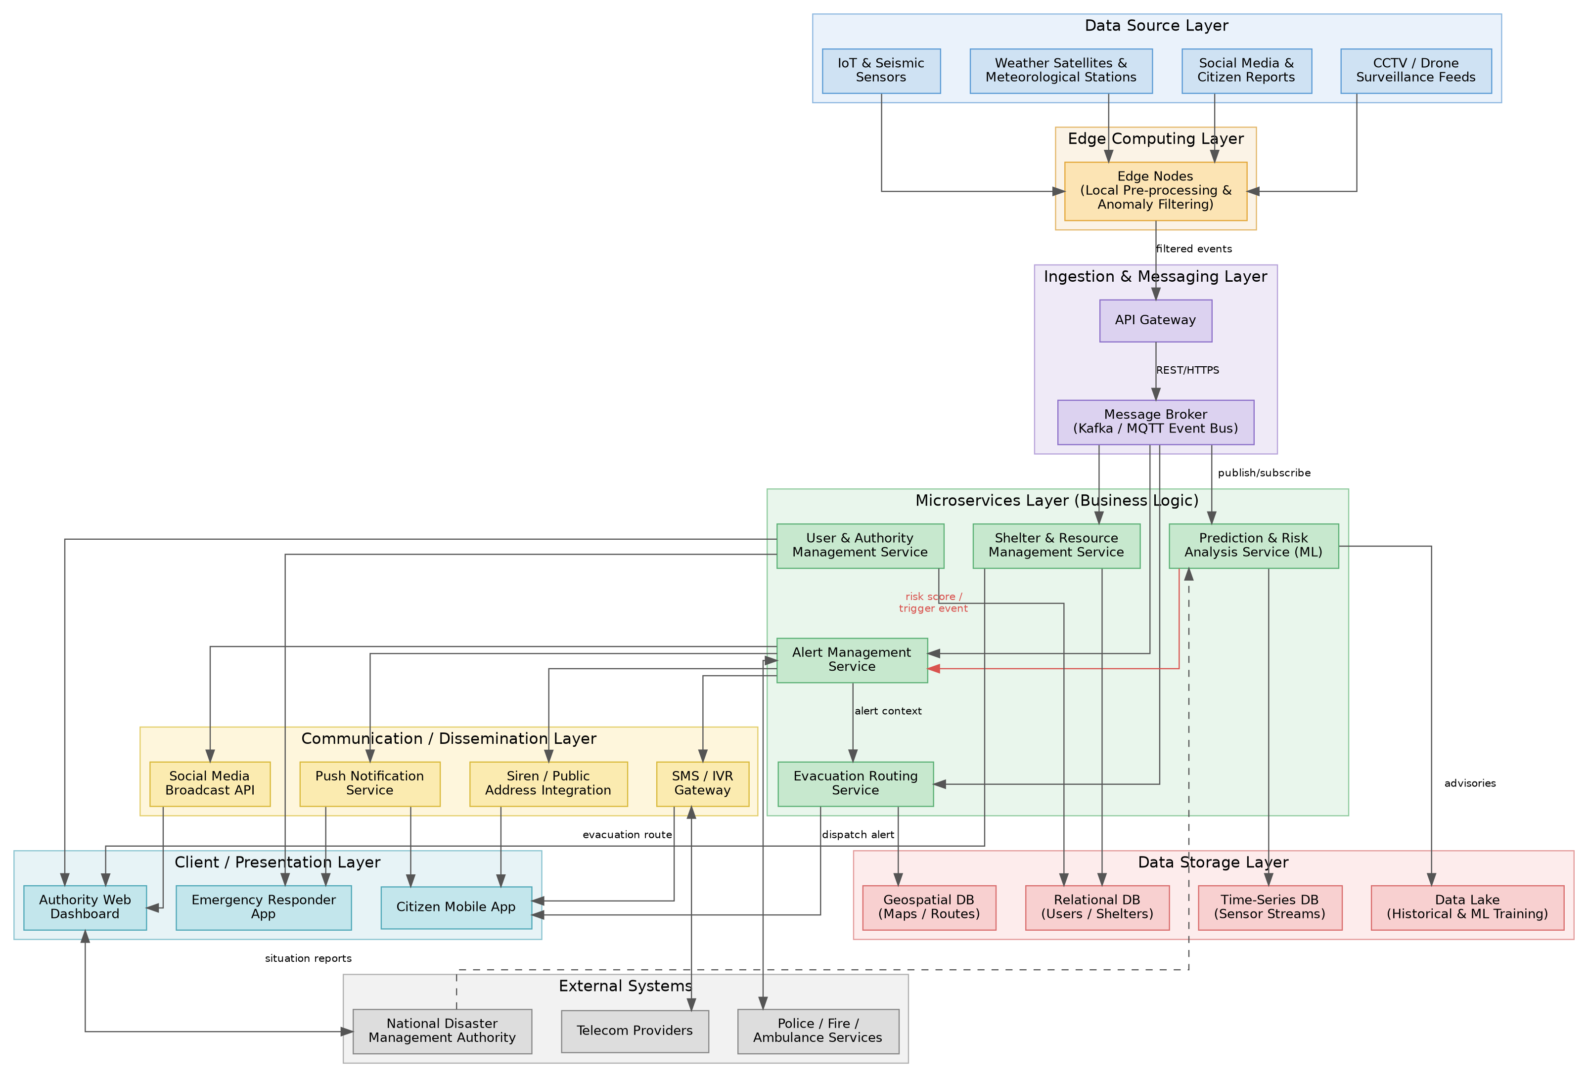
Figure 1: Architecture of the Intelligent Disaster Early Warning and Evacuation Management System

4. Explain Components and Their Interactions

4.1 Component Responsibilities
Layer | Key Components | Responsibility
Data Source Layer | IoT/seismic sensors, weather satellites, social media, CCTV/drones | Originates raw observational data used for disaster detection.
Edge Computing Layer | Edge nodes | Performs local pre-processing and anomaly filtering close to the data source, reducing bandwidth use and latency before forwarding relevant events.
Ingestion & Messaging Layer | API Gateway, Message Broker (Kafka/MQTT) | Authenticates and routes incoming data through a single entry point; the broker decouples producers from consumers via publish/subscribe events.
Microservices Layer | Prediction & Risk Analysis, Alert Management, Evacuation Routing, Shelter & Resource Management, User & Authority Management | Implements the core business logic — risk prediction, alert triggering, route computation and resource coordination — each independently deployable and scalable.
Data Storage Layer | Time-series DB, Geospatial DB, Relational DB, Data Lake | Persists sensor streams, map/route data, user/shelter records and historical data for analytics and ML training, using the database best suited to each data shape (polyglot persistence).
Communication/Dissemination Layer | SMS/IVR gateway, push notifications, siren/PA integration, social media broadcast | Fans a single alert event out across multiple external channels so citizens are reached through whichever channel is available to them.
Client/Presentation Layer | Citizen mobile app, authority web dashboard, emergency responder app | Presents alerts, routes and situational data to end users through role-appropriate interfaces.
External Systems | National disaster authority, telecom providers, police/fire/ambulance | Government and third-party systems that the platform must interoperate with for advisories, message delivery and emergency dispatch.

4.2 Communication Mechanisms
- Edge nodes forward filtered events to the API Gateway over HTTPS/REST; the gateway authenticates the request and forwards it to the Message Broker.
- The Message Broker (Kafka/MQTT) implements asynchronous publish/subscribe messaging so multiple microservices can consume the same event stream independently.
- Microservices communicate with each other using lightweight REST/gRPC calls for synchronous needs (e.g., Evacuation Routing querying the Geospatial DB) and asynchronous events for state changes (e.g., Prediction publishing a “risk-threshold-exceeded” event that triggers Alert Management).
- The Alert Management Service fans a single alert out to multiple external gateways (SMS/IVR, push, siren, social media) in parallel for maximum reach and redundancy.
- Client applications receive updates via push notifications and periodic/streaming API calls to the dashboard backend, and can send citizen reports back into the ingestion pipeline.

4.3 Overall Workflow
(1) Sensors and external feeds continuously stream data to nearby edge nodes. (2) Edge nodes filter noise and forward only meaningful events to the API Gateway, which publishes them onto the event bus. (3) The Prediction & Risk Analysis Service consumes these events, runs its models and computes a risk score. (4) If the risk score crosses a threshold, it publishes a trigger event. (5) The Alert Management Service consumes the trigger, composes the alert and pushes it simultaneously through all dissemination channels while also invoking the Evacuation Routing Service. (6) The Evacuation Routing Service computes safe routes using live geospatial and hazard data and returns them to citizen apps. (7) The Shelter & Resource Management Service updates capacity and resource allocation as citizens move to shelters. (8) The Authority Dashboard aggregates data from all services in real time so officials can monitor and, if needed, override or escalate the response, coordinating with external emergency services.

5. Discuss Quality Attributes

5.1 Scalability
Each microservice can be scaled horizontally and independently based on load; the message broker buffers bursts of sensor/alert events so consumers are not overwhelmed during sudden demand spikes. Auto-scaling policies (e.g., scale the Alert Management and Evacuation Routing services first) can be applied selectively where load is expected to be highest during an active disaster, rather than scaling the entire system uniformly.

5.2 Security
The API Gateway centralises authentication, authorization and rate-limiting for all inbound traffic, preventing spoofed sensor data or forged alert triggers. Sensitive data (citizen location, personal details) is encrypted in transit (TLS) and at rest. Role-based access control restricts dashboard actions to authorised personnel, and inter-service calls within the microservices layer are authenticated (e.g., mutual TLS or signed tokens) to prevent lateral compromise.

5.3 Performance
Asynchronous, event-driven processing avoids blocking calls between services, keeping the detection-to-alert path short. Edge pre-processing reduces the volume of data that must travel to the cloud, cutting latency at the source. Caching of frequently accessed data (e.g., current shelter capacity, cached map tiles) and CDN delivery of the citizen app's static content further reduce response times.

5.4 Reliability
The event-driven design with a durable message broker ensures events are not lost even if a downstream consumer is temporarily unavailable — the broker retains and redelivers messages. Retry policies and circuit breakers between services prevent a slow or failing dependency from cascading. Redundant delivery across multiple alert channels (SMS, push, siren, social media) means a citizen is very likely to receive at least one alert even if one channel fails.

5.5 Maintainability
Each microservice owns its own codebase, data store and deployment pipeline, so a change to, say, the Prediction model does not require redeploying the Evacuation Routing service. Well-defined API/event contracts between services allow teams to evolve components independently, and the internal layered structure of each service keeps business logic, data access and presentation concerns separated for easier testing and debugging.

5.6 Availability
Services are deployed across multiple availability zones/regions with automatic failover, so regional infrastructure damage from the very disaster being monitored does not take the whole system offline. The citizen mobile app caches the last known alert and route information for offline access when connectivity is disrupted. Health checks and orchestration (e.g., Kubernetes) automatically restart or reroute traffic away from failed service instances.

6. Justify Architectural Decisions

6.1 Rationale
The hybrid microservices plus event-driven approach was chosen because the problem domain is inherently reactive (respond to unpredictable real-world events), highly variable in load, and life-critical, so no single component may become a bottleneck or single point of failure. Decoupling services through an event bus mirrors the natural “detect → predict → alert → respond” workflow of disaster management, while allowing each stage to be engineered, tested and scaled on its own terms.

6.2 Trade-offs Considered
- Operational complexity vs. resilience: Microservices introduce deployment, monitoring and inter-service-communication overhead compared to a monolith, but this complexity is accepted because independent scaling and fault isolation are essential for a life-safety system.
- Eventual consistency vs. strict consistency: The event-driven design favours eventual consistency (e.g., a slight delay before the dashboard reflects the latest shelter count) in exchange for higher throughput and availability; this is acceptable because most disaster-management data does not require strict ACID transactions across services.
- Infrastructure cost vs. redundancy: Multi-region deployment and multi-channel alerting increase infrastructure cost, but the trade-off favours redundancy given the life-safety consequences of a missed alert.
- Development speed vs. flexibility: A simpler layered monolith would have been faster to build initially, but would not meet the scalability and fault-isolation requirements identified in Section 1, so the additional upfront design effort for microservices was judged worthwhile.

6.3 Support for Future Enhancements and Long-Term Maintainability
The chosen architecture supports future growth in several ways:
- New disaster types or data sources (e.g., additional sensor networks, satellite feeds) can be onboarded by adding new producers to the event bus without modifying existing services.
- New alert channels (e.g., smart-home integrations, wearable alerts) can be added as new subscribers to the Alert Management Service's trigger events.
- Prediction models can be upgraded or replaced independently as better ML techniques become available, since the Prediction service is isolated behind a stable event/API contract.
- The API-first, loosely-coupled design simplifies integration with additional government or NGO systems as partnerships expand.
- Because each service is independently deployable, the system supports continuous integration/continuous deployment (CI/CD), enabling frequent, low-risk updates without full-system downtime.
Overall, the hybrid microservices and event-driven architecture directly addresses the functional needs and the critical non-functional requirements — scalability, availability, reliability, performance, security and maintainability — identified in the requirements analysis, while remaining extensible for the system's long-term evolution.

